Neighborhood Health Profile

Brandon Wong

Department of Geography, University of Washington

Geog 381: Maps and Health

Maggie Wilson

July 16th, 2021

Reference Maps

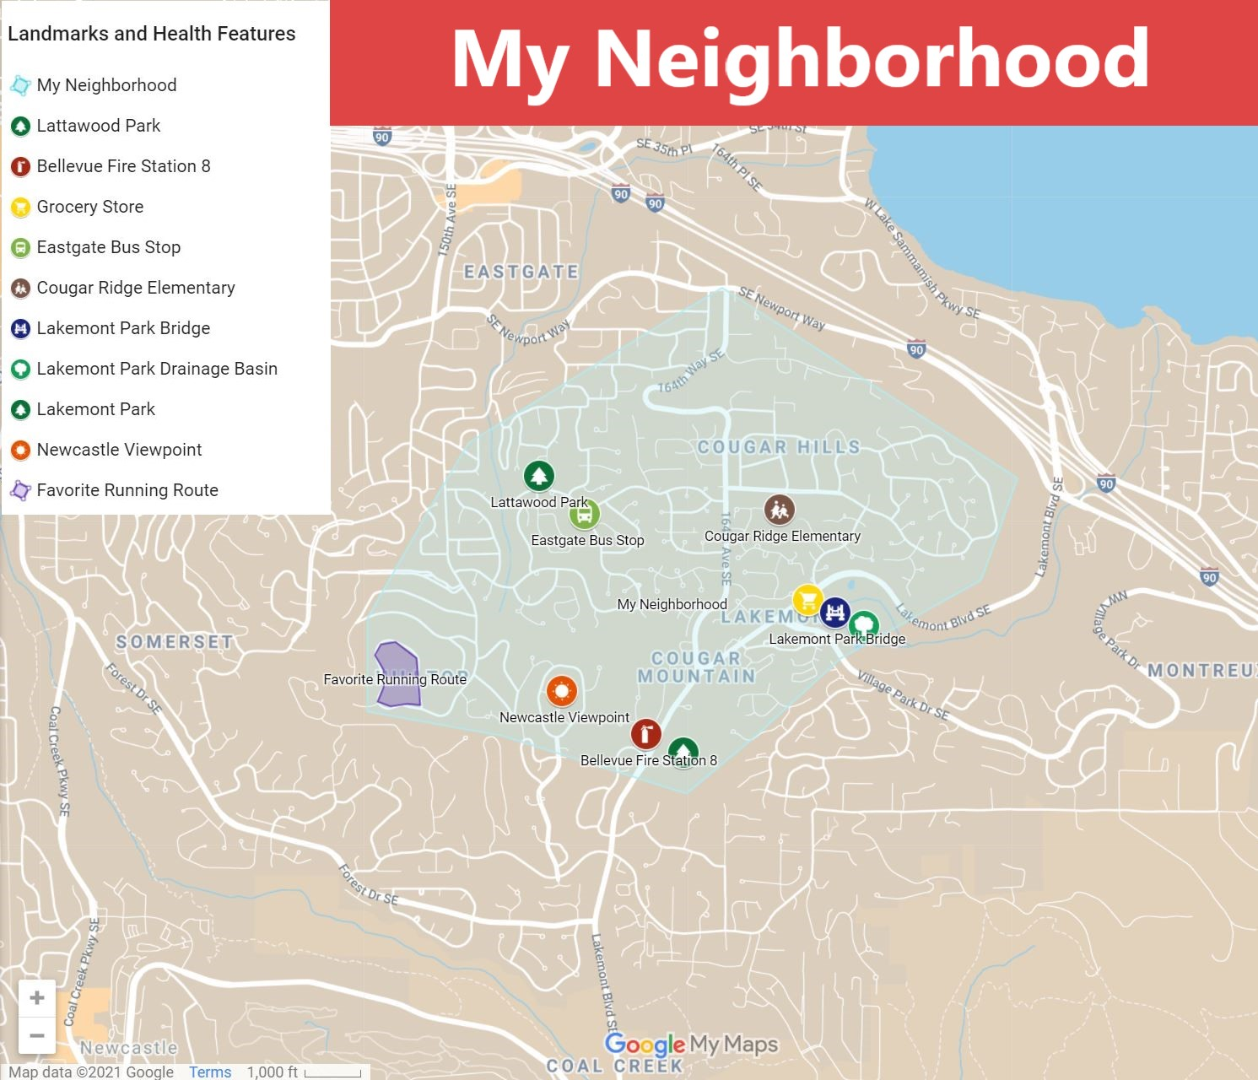

**Figure 1.** My neighborhood landmarks and health features are marked by unique symbols on Google MyMaps.

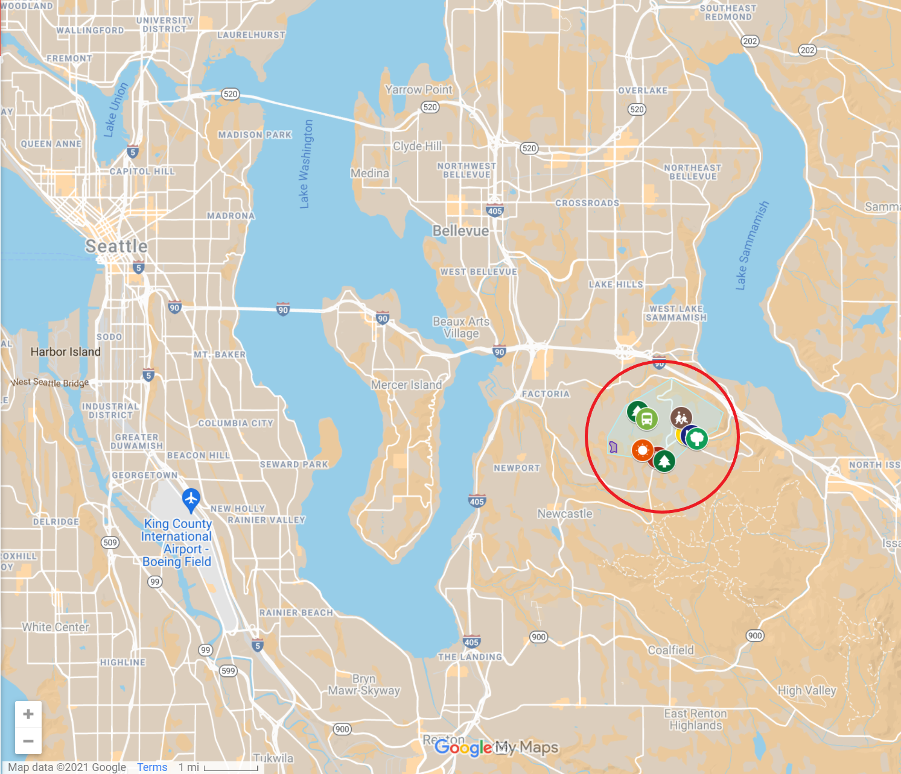

**Figure 2.** A zoomed-out view of my neighborhood map is in figure 1. My neighborhood is located in South Bellevue which is in a suburb East of Seattle. The zip code associated with my area is 98006.

Thematic Maps

| Zip Code | Annex(s) | City |
| --- | --- | --- |
| 98033 | South Juanita, North Rose Hill, Moss Bay, South Rose Hill | Kirkland |
| 98052 | Sammamish Valley, SouthEast Redmond, Overlake | Redmond |
| 98039 | Eastland | Medina |
| 98004 | Hunt’s Point, Yarrow’s Point, NorthWest Bellevue, West Bellevue, Beaux Arts Village | Bellevue, Clyde Hill |
| 98005 | Bridle Trails, Wilburton, Crossroads | Bellevue |
| 98006 | Factoria, Newport, Eastgate | Bellevue |
| 98007 | Lake Hills, Highlands | Bellevue |
| 98008 | Northeast Bellevue, West Lake Sammamish | Bellevue, Redmond |
| 98056 | Newport Hills, May Creek, Kennydale, Highlands Park | Newcastle, Renton |
| 98059 | Cougar Mountain, Coalfield, East Renton Highlands | Newcastle, Renton |
| 98027 | Montreaux, Tibbetts Creek Valley, Talus, Squawk Mountain, Sycamore, Park Pointe, Olde Town, Issaquah Highlands, North Issaquah | Issaquah, Mirrormont, Preston |

**Figure 3.**

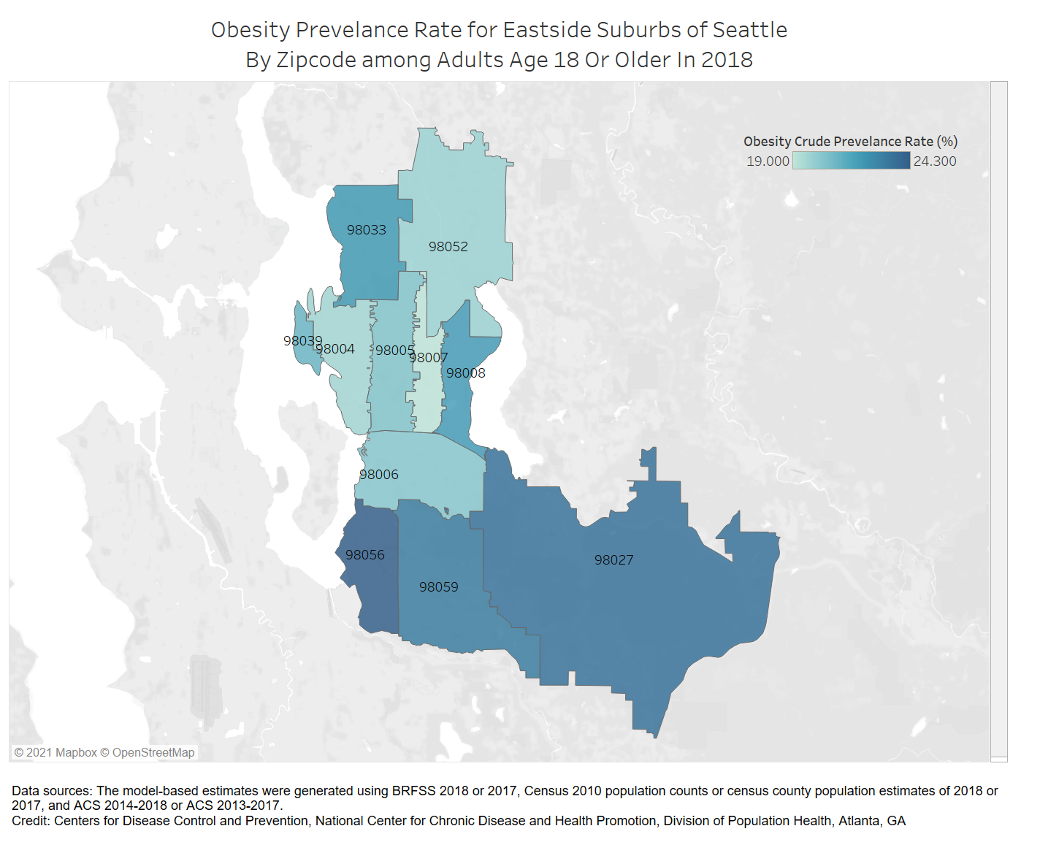

**Figure 4.** Obesity prevalence rate by zip code.

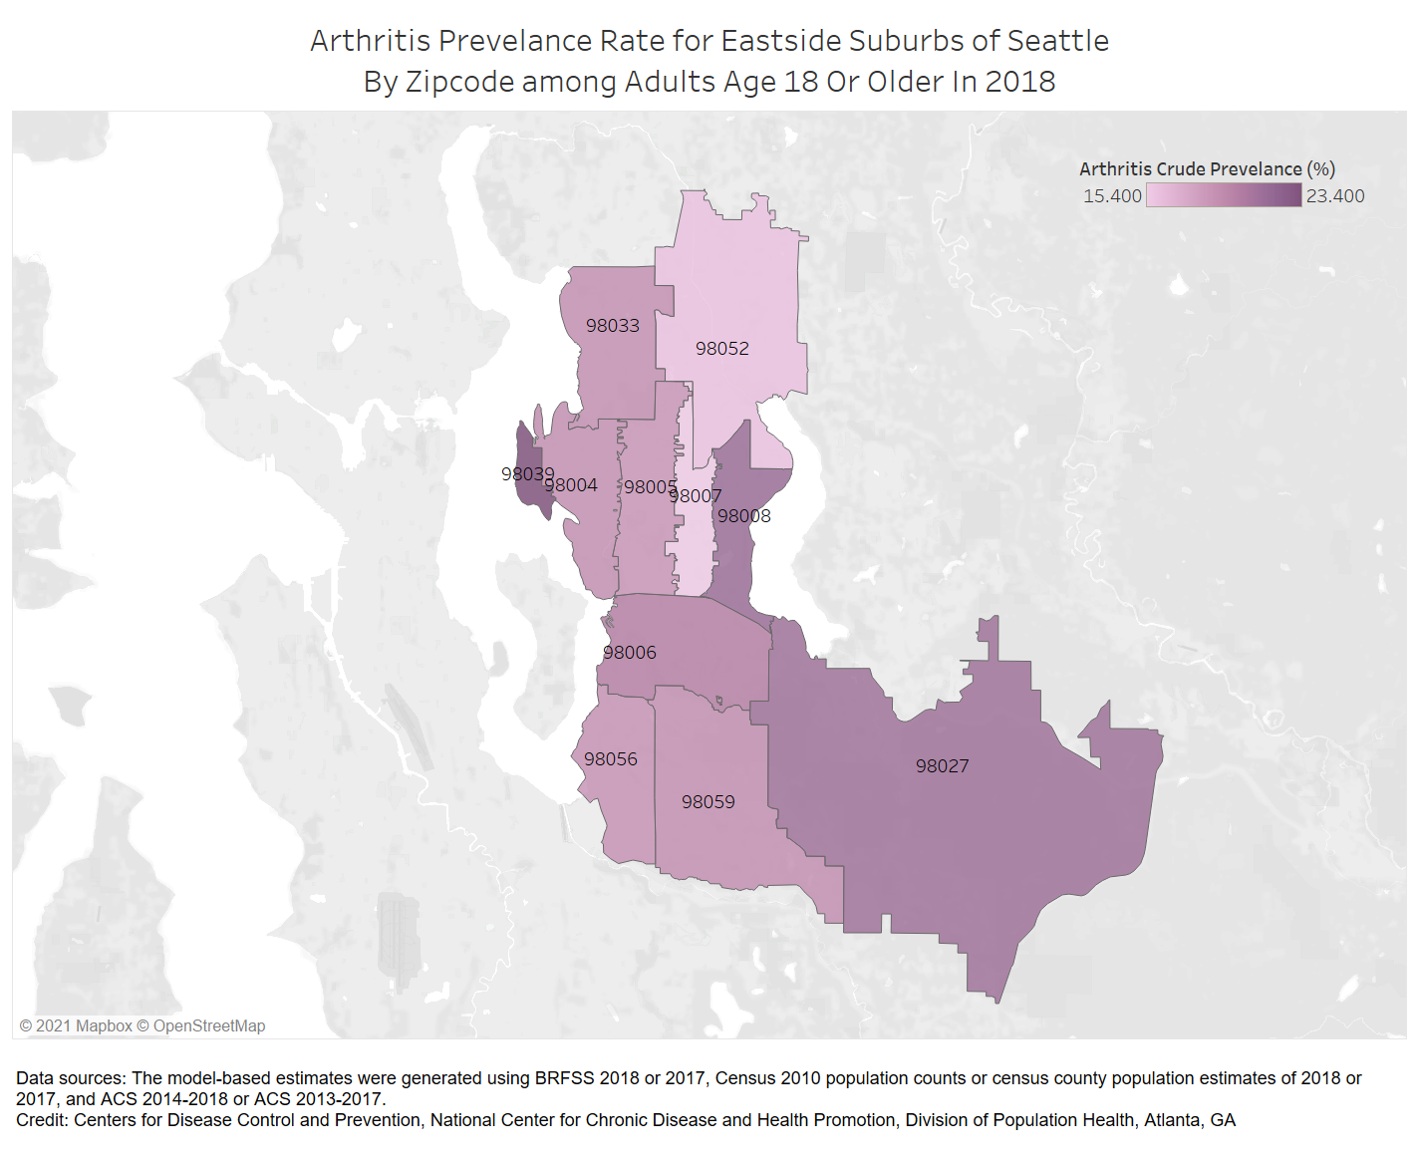

**Figure 5.**

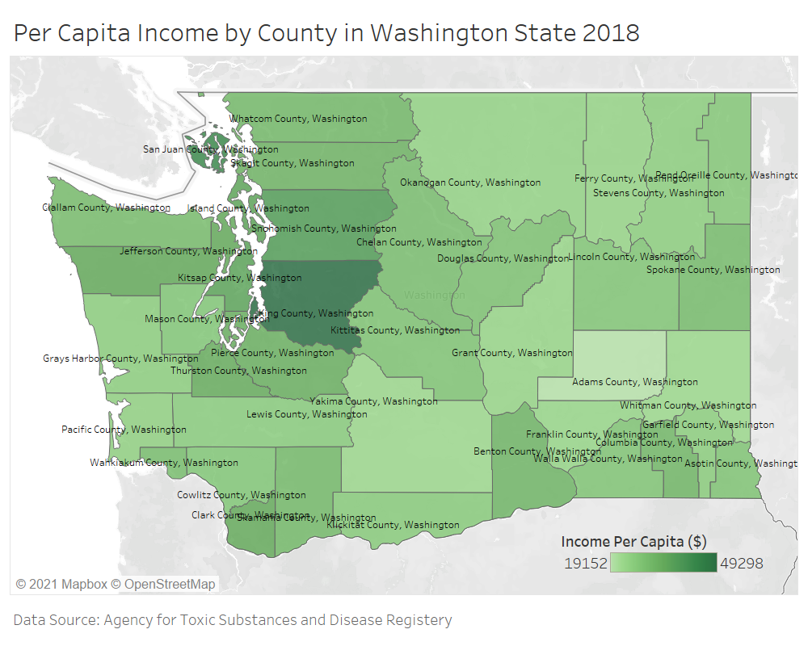

**Figure 6.**

Analysis

My neighborhood is in Bellevue Washington in an area called Lakemont. Specifically, this is in South Bellevue which is close to the intersection between I-5 and I-405. To define the limits of my neighborhood, I consider the streets of Lakemont Boulevard, Newport Way, and 164th Avenue to be the boundary lines. The rationale behind using Lakemont Boulevard as a boundary of my neighborhood is because it separates the border between the city of Bellevue and Issaquah. Furthermore, Lakemont Boulevard South also borders another city called Newcastle. Lastly, Newport Way is also a neighborhood’s northern boundary because it is very close to Lake Sammamish and East Bellevue.

My initial assessment of my neighborhood’s health is that there is plenty of access to food, transportation, education, and green spaces. In figure 1, I included unique symbols for each landmark I identified as sites about the health of my neighborhood. One resource that stands out in my neighborhood is the multitude of parks. There are several parks within three miles of my house and I noticed many of the residents using these as places of leisure and exercise. Some common features of each of these places had been walking paths, playground structures, grass fields, and sports courts. Usually, I would see mothers with young children, middle-aged to elderly people walking, and kids and teens playing sports. Parks seem to be popular in my neighborhood because there are always people there at all times of the day. This is significant when accessing the health of my neighborhood because parks allow for people to maintain their physical and mental health. Another place I observed is a business plaza called Lakemont Village. This location can be seen in Figure 1 near the grocery store and Lakemont Bridge. I believe this site demonstrates the health of my neighborhood the most based on the number of sites on health. I noticed the grocery store in this plaza is very popular and had half of the store dedicated to fresh fruit vegetables, meat, and seafood. Other businesses I saw in this plaza is a veterinary, dental, and eye clinic. From personal experience, I wasn’t aware of these health clinics before this neighborhood analysis but I found it reassuring that the neighborhood has high access to these resources. Judging from these initial observations, I believe my neighborhood is healthy. However, a common group of people I saw was middle age to elderly people. Although I did not visibly observe anyone with significant health issues, there is a multitude of diseases that affect the elderly population in the US. So in concern for the elderly population of my neighborhood, I wanted to study the diseases of obesity and arthritis and see if there is any correlation between the two.

Obesity causes a multitude of health issues including heart disease, stroke, cancer, and diabetes II. In general, obesity is increasing due to diet, lack of physical activity, and increased sedentary behavior. According to the CDC, a person is considered obese if their BMI (Body Mass Index) is 30 or greater. To study how obesity affects my neighborhood, I chose to create a choropleth map displaying obesity prevalence data from the CDC which is shown in Figure 4. This map shows prevalence based on zip code because this was the public data I had access to. To provide further context, I included a table (Figure 3) so that annexes and cities can be easily identified. My particular neighborhood is within the zip code 98006. The general impression I get from this map is that the area of data shown has little variation. Between the areas with the lowest and the highest prevalence is only five percent. My zip code seems to be towards the lower prevalence which is indicated by its lighter color which I interpret at 17%. When comparing this to the King County average 0f 21.5%, most of these areas fall underneath or slightly above the average. Additionally, comparing my neighborhood’s prevalence to the national average at 42.4%, it is significantly lower. This would mean in general my neighborhood’s population is very healthy. To determine why this might be the case, I found articles that explore factors that influence the obesity of a neighborhood. In the article *Obesity and Urban Environments*, there are several factors including urban layout, physical activity, diet, and environment. One example is that people tend to exercise more frequently based on the walkability of their neighborhood. However, some neighborhoods disincentive this based on urban sprawl that has “low-density suburban development, with segregated land uses low connectivity, high automobile dependence” (Congdon, Queen Mary University). From what I have observed in my neighborhood, many people rely heavily on using cars for transportation and some roads are without sidewalks. However, what seems to compensate for this is the many parks as mentioned earlier. While obesity seems to be a disease largely prevalent in the US, my specific neighborhood has a low prevalence.

Arthritis was also a disease I studied based on my initial observations of seeing more elderly and middle-aged residents in my area. When observing my choropleth map in Figure 5, there seems to be a higher prevalence of arthritis at about 20%. Compared to the national average of 22% for adults 18 or older, the prevalence is similar. But, despite seeing similar rates for adults, I also explored if potential relations between age and arthritis. Among further research, an article by the *Institute of National Health* found that there is a prevalence of 50 percent for people age 65 or older. However, this seems unlikely in representing my neighborhood because I found that Bellevue’s population of people 65 and older to be only 14 percent according to the US Census Bureau. Rather, I discovered that there is a stronger correlation between obesity and arthritis. Excess weight causes joint pain and moderate weight loss can improve symptoms such as limited function, pain, and disability. Also, studies have found that weight loss can improve “physical function by 28%” (Hootman, Helmick, Brady NIB). I also noticed a correlation between both maps where the prevalence of obesity was similar to prevalence the of arthritis. Even when comparing the range of the prevalence rate there are still similarities where the prevalence rate is between 15 to 25 percent. Although it is more difficult to observe arthritis in person, there are clear indications from my map in figure 5 that there is a relatively low prevalence of arthritis within my area.

To analyze why might my neighborhood may experience low rates of obesity and arthritis, this may have to do with social determinants of health. One key determinant discussed in the lecture is socioeconomic status. In my neighborhood, many people have high socioeconomic status. As seen in figure 6, King County has the highest per capita income at $49,298. Furthermore, I found that my city of Bellevue has a median income of $120,456 as per the US Census. According to the CDC, obesity is dependent on socioeconomic status, education level, and race. In this study, it was found that adults in the lower-income and higher-income had a lower obesity prevalence rate of 32 percent as compared to the middle income. In the state of Washington, the low income and higher income is defined by 26,000 and 188,000 respectively while the middle income is 80,000. While income may not be the sole reason for obesity, there is a significant role. When thinking about diet, people of lower income tend to eat fast food or processed foods due to the cost and avert from buying fresh foods that may be more expensive. These might be detrimental because these foods tend to be high in calories which can consist of fats and carbohydrates. This also might reflect in their behavior as there might be more inconsistent working hours and meal times that may make it more difficult to track calorie intake. In my neighborhood, the median income is clearly above the median of Washington which leads me to believe residents have access to nutrition and time to exercise. In a study in Taiwan, lower socioeconomic status was perceived as a risk of developing Rheumatoid arthritis. With people of lower-income (people making less than 1,000 USD), there was a higher prevalence rate of about 3.65/10,000 verses 2.58/ 10,000 for middle-income women. When comparing this to my neighborhood, there is adequate access to healthcare and many people can afford health insurance. I find despite there being a relation between age and arthritis, there may also be other determining factors such as the type of work people are involved in. Usually, in blue-collar work, there is more manual labor which could lead to developing arthritis earlier on.

While my initial perceptions were that my neighborhood is healthy, my understanding of the reasoning behind it has changed. It may be true that I observed much of the elderly population in my area walking and visiting parks local in my neighborhood, the diseases I had analyzed may not be affecting them as much as I had previously thought. My neighborhood had a low prevalence of both obesity and arthritis which seems to be in part due to the socioeconomic status of my neighborhood. As mentioned by Farmer in *Structural violence and clinical medicine,* understanding diseases is inherently biosocial. People’s livelihood and physical health are affected by social determinents. This includes considering the population, their behavior, and habitat. In the US, socioeconomic status is a large determining factor of access to health resources. Understanding how health is determined may lead to how we can create a more just system of health for all.

Citations

ASTR. Social Vulnerability Index. (2018).

<https://www.atsdr.cdc.gov/placeandhealth/svi/index.html>

CDC. Places: Local Data for Better Health. (2018).

<https://www.cdc.gov/places/>

Congdon P. (2019). Obesity and Urban Environments. International journal of environmental research and public health, 16(3), 464. <https://doi-org.offcampus.lib.washington.edu/10.3390/ijerph16030464>

Explore Census Data. (n.d.). https://data.census.gov/cedsci/profile?g=1600000US5305210.

Hootman, J. M., Helmick, C. G., & Brady, T. J. (2012). A public health approach to addressing arthritis in older adults: the most common cause of disability. American journal of public health, 102(3), 426–433. <https://doi.org/10.2105/AJPH.2011.300423>

Yang, D. H., Huang, J. Y., Chiou, J. Y., & Wei, J. C. (2018). Analysis of Socioeconomic Status in the Patients with Rheumatoid Arthritis. International journal of environmental research and public health, 15(6), 1194. <https://doi.org/10.3390/ijerph15061194>